Room A
AQ1 Umbilical Hernia in a cirrhotic patient.
Stem: You are seeing a consult in the emergency department. Patient is a 39-year-old male w/ history of alcohol abuse, prior IV drug use and chronic hepatitis C. He complains of increased abdominal pain over the past two days, worsening overnight. He does not have regular care with a PCP.
PE: Tachycardic to 110 on presentation, normotensive. He has a visible umbilical bulge with overlying erythema and diffuse tenderness to palpation. There is some drainage of clear fluid with palpation.
Labs: Tbili 3.2; AST 320 ALT 140 ALP 100; albumin 2.5, INR 1.7.

Discussion
Any other information you would like to know?
- History of ascites? Tapped? (Remembers they had to remove some fluids from his belly but can’t recall when that was done or where)
- History of encephalopathy? No

What is your most likely diagnosis in this condition and What is your Differential Diagnosis?
- Liver cirrhosis / Incarcerated umbilical hernia - What Class? “CHILD C” -- what values goes into the CHILD classification “Bilirubin level, INR, albumin, history of ascites, history of encephalopathy.”

- Differential Diagnosis?
- Strangulated hernia
- Spontaneous bacterial peritonitis
How would you manage this patient?
- Resuscitate the patient, ensure two large bore IV’s
- CT Abdomen / Pelvis w IV contrast

While waiting for the CT scan to be done, the bulge ruptured and started actively draining, what are you going to do ? (For the examiners : Residents should know, need for Urgent herniorrhaphy , Medical mgt of the ascites & Closure of wound in layers)

proceed to OR urgently. Repair the Hernia, Closure in layers.

Would you use a mesh?!
a. Sterile field → mesh (Sublay vs. intraperitoneal to prevent issues with seroma if done in onlay fashion)
b. Contaminated field → tissue repair vs. absorbable mesh

How would you manage post-op ascites?
a. Serial paracentesis vs. drain-placement. Either is acceptable
b. Dietary salt restriction to < 1.5 to 2 grams
c. Fluid restriction to 1 to 1.5 L daily not necessary unless hyponatremic d. Diuretics but don’t use thiazides.
- Start spironolactone and Lasix together at 100 mg/40mg. can increase to 400mg/160 mg. titrate up together weekly. Goal of net negative 1 to 2 pounds daily

e. Arrange for follow up with GI
Scenario 1: Same patient, now POD6 following repair. The nurse pages you and says the patient was getting out of bed when he noticed a sudden gush of fluid from his incision site. You evaluate the patient, and the incision looks intact. How do you proceed?

a. Open the wound, probe to ensure fascia intact.
b. If dehisced, needs the operating room.

Can consider another option of managing the leakage with paracentesis and hope that seals. High rate of wound complications and mesh infections

Scenario 2: Another patient, 43-year-old male, again with a history of cirrhosis, presenting to clinic with a freely reducible umbilical hernia, but reports it is causing symptoms on a daily basis and he would like to have it fixed. How do you proceed?
- Determine Child's class and maximize medical therapy to control ascites and liver function.…
For ,,,,
- Childs A: fix the hernia on an elective basis.
- Childs B: depends on comorbidities, ability for follow up, compliance. It’s a grey area.
- Childs C: Don’t fix these electively.

Pitfalls:
- Failure to identify / know CHILD classification.
- Failure to address ascites perioperatively.
- Failure to proceed to OR urgently if hernia ruptures.
- Residents should know, need for Urgent herniorrhaphy , Medical mgt of the ascites & Closure of wound in layers)

References: Coelho JC, Claus CM, Campos AC, Costa MA, Blum C. Umbilical hernia in patients with liver cirrhosis: A surgical challenge. World J Gastrointest Surg. 2016;8(7):476-482. doi:10.4240/wjgs.v8.i7.476

AQ2 S/P CHOLECYSTECTOMY AND OTHER POST-OP COMPLICATIONS
Stem: Patient is a 65-year-old man who presents to the emergency department 3 days after laparoscopic cholecystectomy for acute, calculous cholecystitis. He has been having worsening epigastric and RUQ abdominal pain, PO intolerance, chills, fevers, jaundice, darkened urine.
No significant past medical or surgical history.
Exam: HR 114bpm, BP 94/37; 94% on RA, Temp. 38.8C, Ill appearing, lethargic, jaundice, scleral icterus Mildly distended, TTP in the RUQ and epigastrium.
labs: WBC 16.4k; Tbili 4.3; AST 143; ALT157; ALK Phos 312; Creatinine 1.73 (normal 0.90)

Discussion
What’s one initial study would you like to order now?
RUQ US

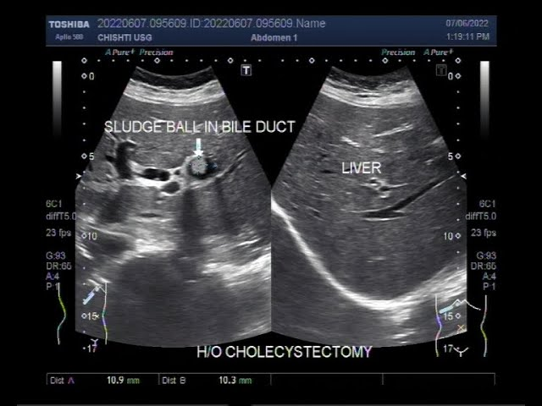

-dilated intra and extrahepatic bile ducts with CBD measuring 1.1cm, mild RUQ fluid, and distal common bile duct stone.

How are you going to manage this patient.
- Sepsis workup.
- Resuscitation / hydration/ antibiotics.
- ERCP: You are not credentialed to do it and your GI colleague is on vacation.
- PTC: Your IR colleagues are not available.
- Urgent CBD exploration:
  - Open CBD Exploration.
  - Kocherize the duodenum, palpation of the common bile duct to assess location/mobility of the stone, exposure of anterior CBD
  - Place sutures at the 10 and 2 positions and make an anterior vertical ductotomy.
  - Flush duct with small diameter red rubber and pass a biliary Fogarty catheter proximally and distally until all stones are removed.
  - Choledochoscope can be used with wire basket to retrieve challenging stones.
  - Close ductotomy over a 14 fr T-tube
  - Perform completion cholangiogram.
  - Leave JP drain.

Scenario 2: Same patient arrives, RUQ US notes intra and extra hepatic ductal dilation, mild fluid, no stone is appreciated. You are now in a tertiary center with all images and expertise available.
- ERCP or MRCP or advanced imaging to delineate etiology
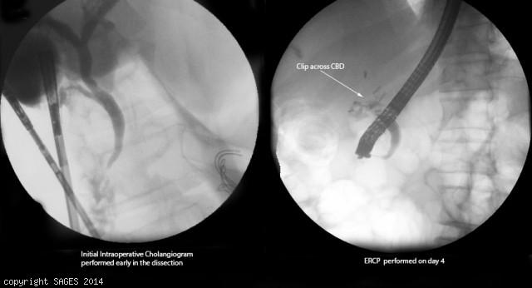
Concern for clip across CBD
- Antibiotics
- IR consultation for PTC.
You take the patient to the OR for repair, how do you repair the following?
- Injury < 50% circumference, not caused by cautery - Repair over T tube.
- Transection < 1 cm in size and away from bifurcation - End to end anastomosis.
- More severe injury, or close to the bifurcation: Hepaticojejunostomy

Scenario 3: Same patient however with AST/ALT and Alk phos within normal limits, Tbili slightly elevated to 2.4. RUQ US shows concern for large fluid collection in the RUQ.
1. HIDA: Shows biliary leak.
2. ERCP obtained → cystic duct stump leak confirmed → Sphincterotomy and Stent
3. IR for drainage of RUQ fluid collection if symptoms do not resolve, persistent leakage or septic.

Pitfalls:
- Failure to recognize / address sepsis.
- Failure to identify cholangitis and address CBD obstruction urgently .

References: Zackria R, Lopez RA. Postcholecystectomy Syndrome. [Updated 2022 Aug 29]. In: StatPearls [Internet]. Treasure Island (FL): StatPearls Publishing; 2022 Jan-. Available from: https://www.ncbi.nlm.nih.gov/books/NBK539902/

AQ3 MVC WITH PELVIC FRACTURE
Stem: Stem: 43-year-old male is ejected 20 feet away from his motorcycle while traveling at highway speeds. Denies LOC and was helmeted. He was given one liter IV fluid bolus en route to the ER for a systolic blood pressure of 80mmHg.
Exam on arrival to the trauma bay: Patient is responsive but confused. Oxygen saturations are mid 90s on room air. Heart rate is 120 and systolic blood pressure is 80 mmHg. GCS is 14. Primary survey significant for mild abdominal tenderness, hip tenderness, and diffuse scattered abrasions. He has two large bore IVs in place.
Discussion
How are you going to manage this patient?
- ATLS
- Transfuse blood products (start with 2 units PRBCs)
- Trauma panel (CBC, CMP, lactate, coagulation studies, type and screen, drug screen) : Pending
- CXR: unremarkable
- Pelvic XR
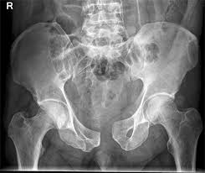
demonstrates widening of the pubic symphysis by 3 cm.
- FAST exam suboptimal due to body habitus
- DRE to r/o rectal injury.
What is your differential diagnosis?
- Solid organ injury.
- Pelvic fracture.
- Long bone fracture.
- Genitourinary injury
- Rectal injury
What would you like to do now?
1.Pelvic binder. (Resident should know binders (or alternatively bed sheet with holes at groins for IR access if needed) are positioned at the level of the great trochanters.
2. Reassess vitals and mentation, If patient stabilizes after 2U PRBCs and pelvic binder placement, proceed to CT with IV contrast.
What are the three predominant force vectors?! Vertical, Lateral compression & anteroposterior
Which vector of force leads to “open book” pelvic fracture pattern? Anteroposterior
Which force vector is associated with the greatest EBL? Anteroposterior due to disruption of lumbosacral venous plexus.
Scenario: Patient’s heart rate and blood pressure improve with 2U PRBCs, but FAST shows fluid in rectovesical pouch fluid, you take the patient to the OR and you encounter large pelvic hematoma →
- Try to keep the initial incision out of the lower abdomen so that if laparotomy is negative and has a pelvic hematoma then can-do pelvic packing.
- Make 6-8cm midline incision from pubic symphysis cephalad.
- Blunt digital dissection of preperitoneal space for packing.
- Temporary closure
- Consider ex fix if Ortho available and patient stable.
What if patient initially stabilizes but has ongoing transfusion requirements >4U PRBCs / 24hr) Now what? IR
What if you encounter blood on DRE? Obtain rigid sigmoidoscopy to exclude rectal injury.
What if you see blood at the meatus? Get retrograde urethrogram → There is injury to the urethra, the urologist is on vacation what would you do? Place percutaneous suprapubic catheter.
What if you place a foley then you see hematuria, patient is hemodynamically stable now?! CT scan
- It shows extraperitoneal bladder injury → Manage nonop with bladder decompression via foley x2 weeks.
- It shows Intraperitoneal bladder injury → OR for repair.
Pitfalls:
- Resident should know binders (or alternatively bed sheet with holes at groins for IR access if needed) are positioned at the level of the great trochanters.
- Failure to assess for blood at the meatus or on digital rectal exam.
References: Tullington JE, Blecker N. Pelvic Trauma. [Updated 2022 Aug 8]. In: StatPearls [Internet]. Treasure Island (FL): StatPearls Publishing; 2022 Jan-. Available from: https://www.ncbi.nlm.nih.gov/books/NBK556070/

